The goal of the app is to allow many demographics an accessible and simple way to read and interpret the 2020 election results

Crazy Eights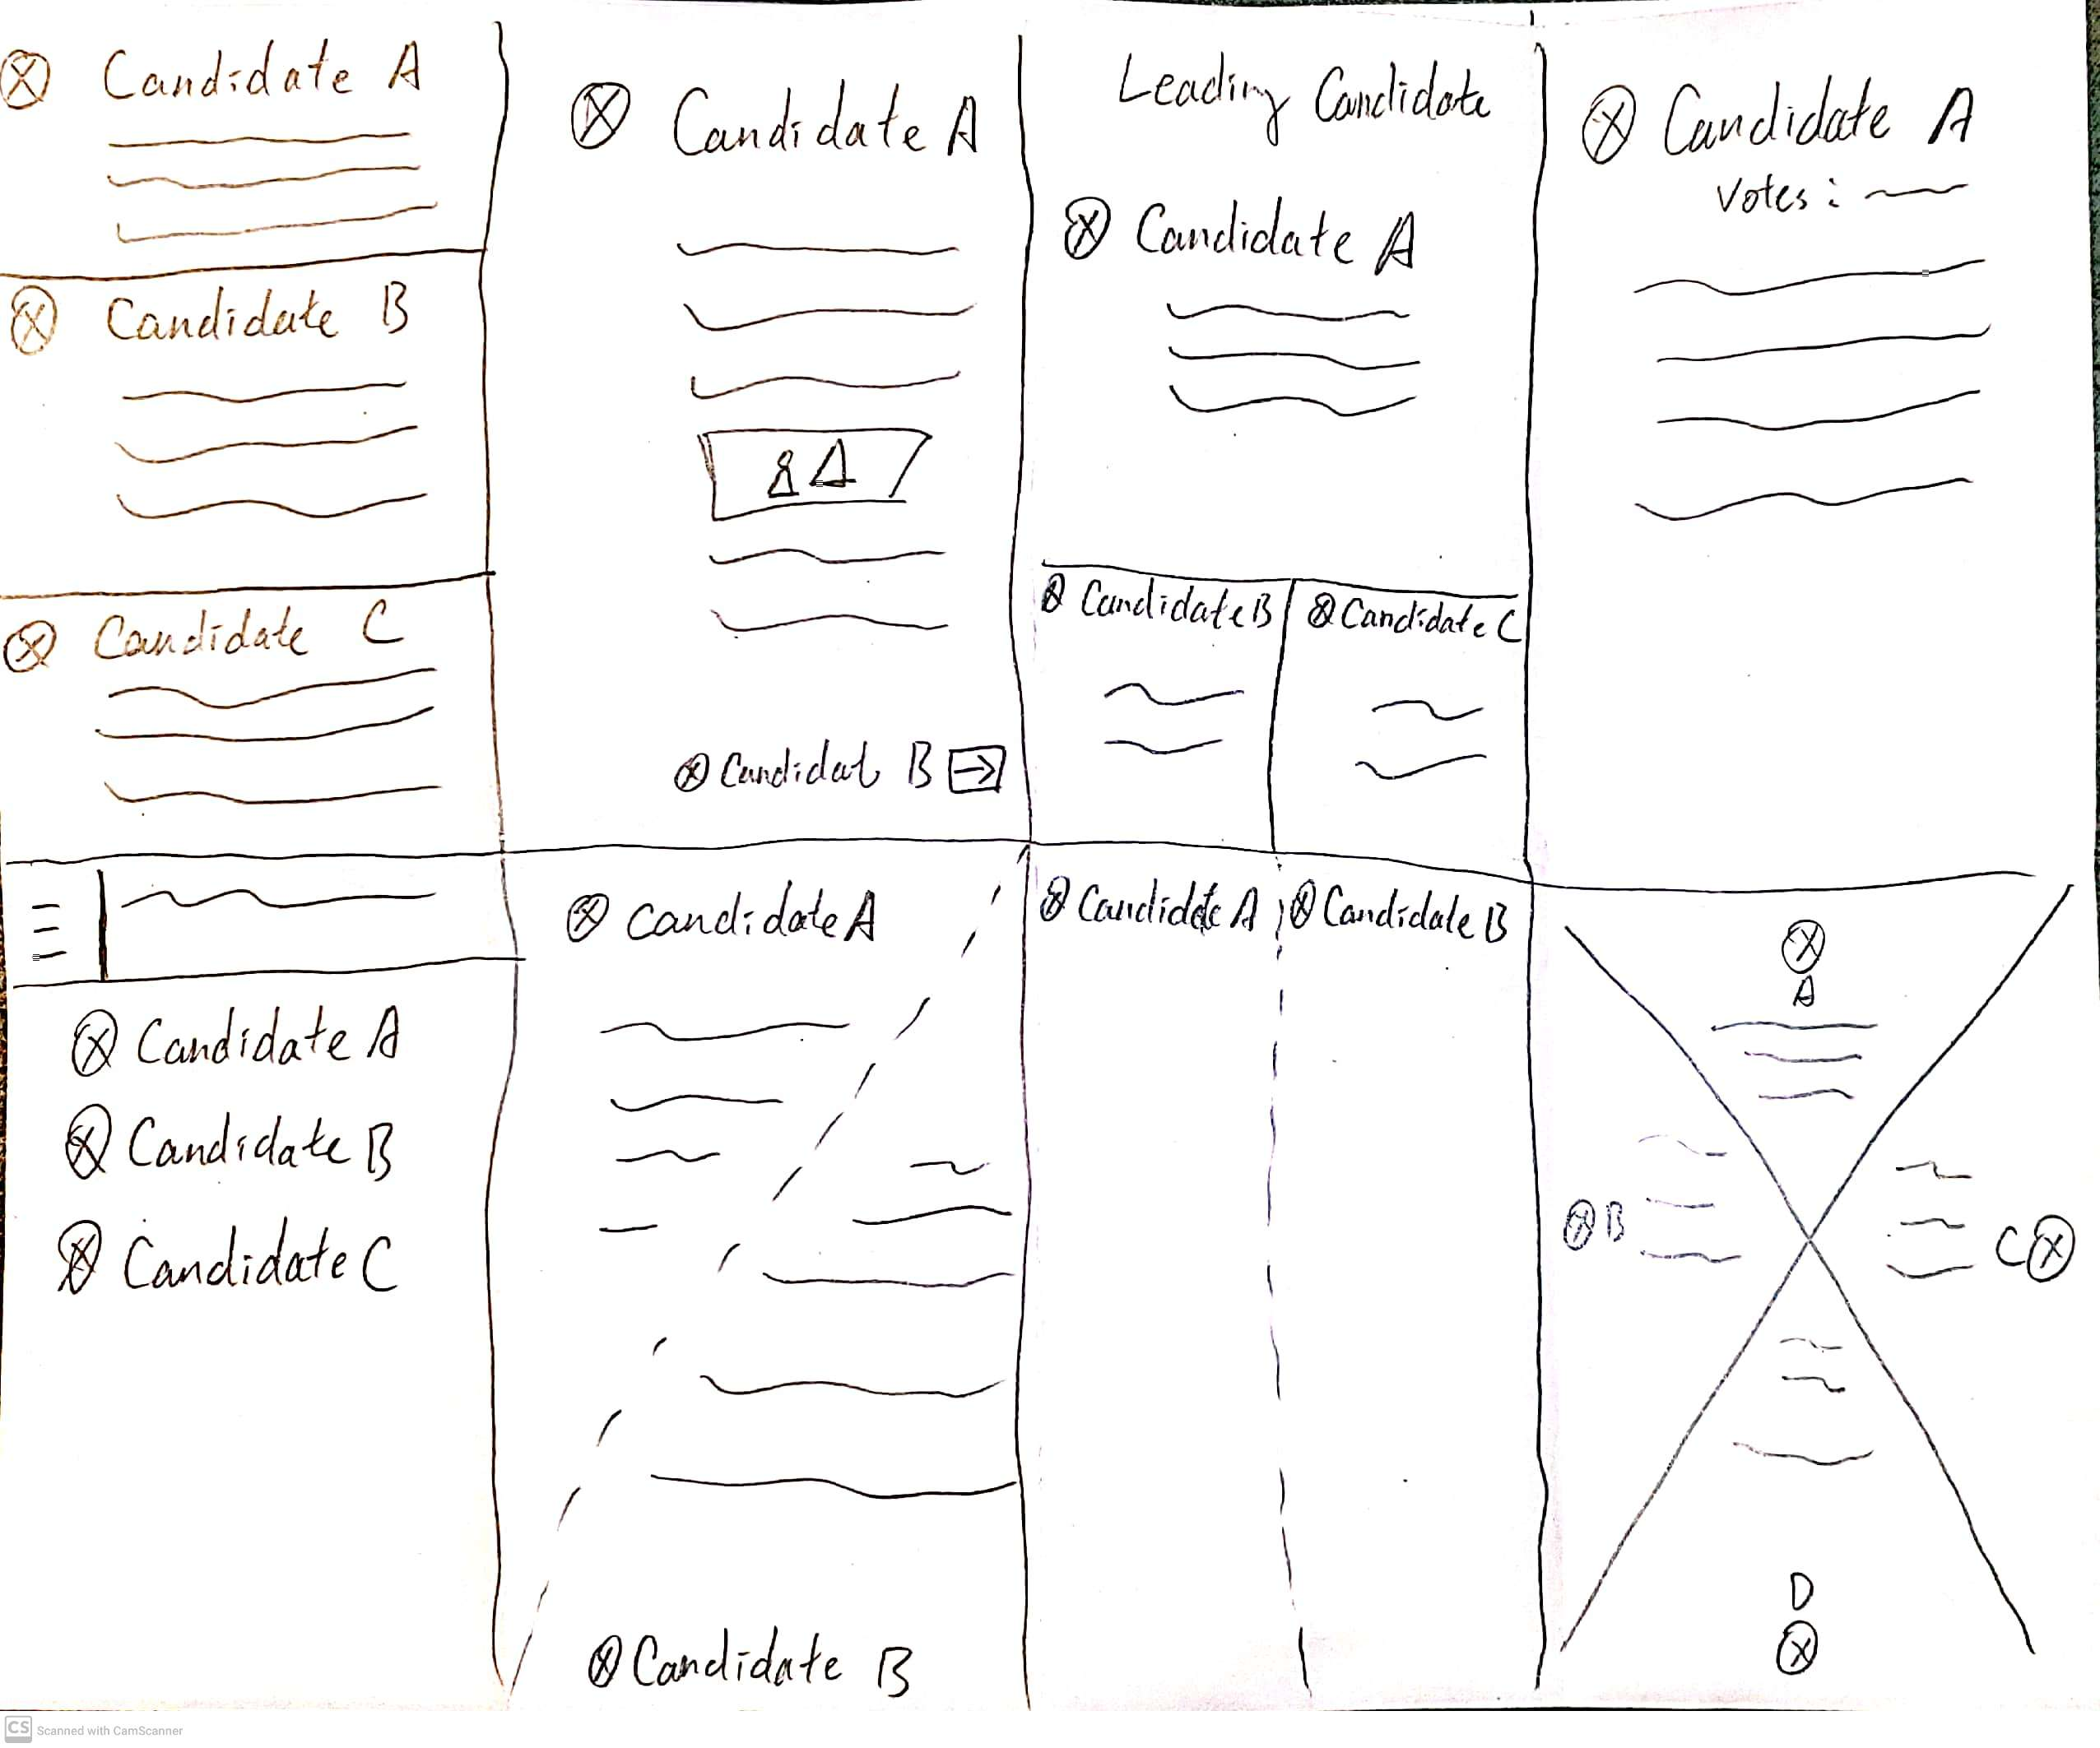

Basic info of candidates

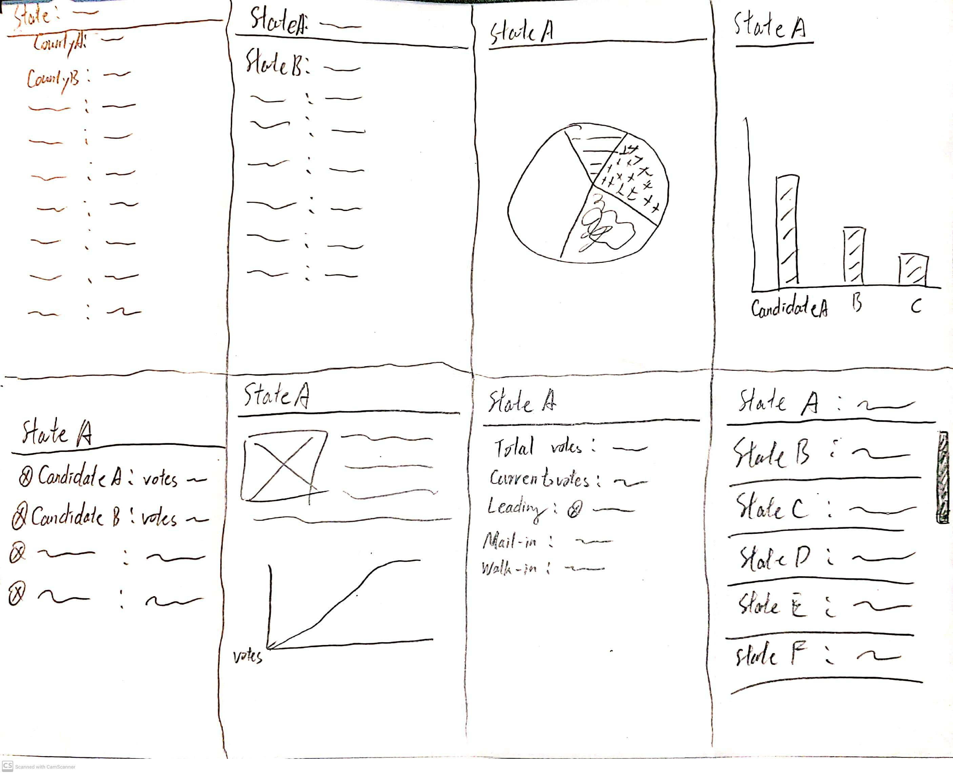

Votes prediction and analysis

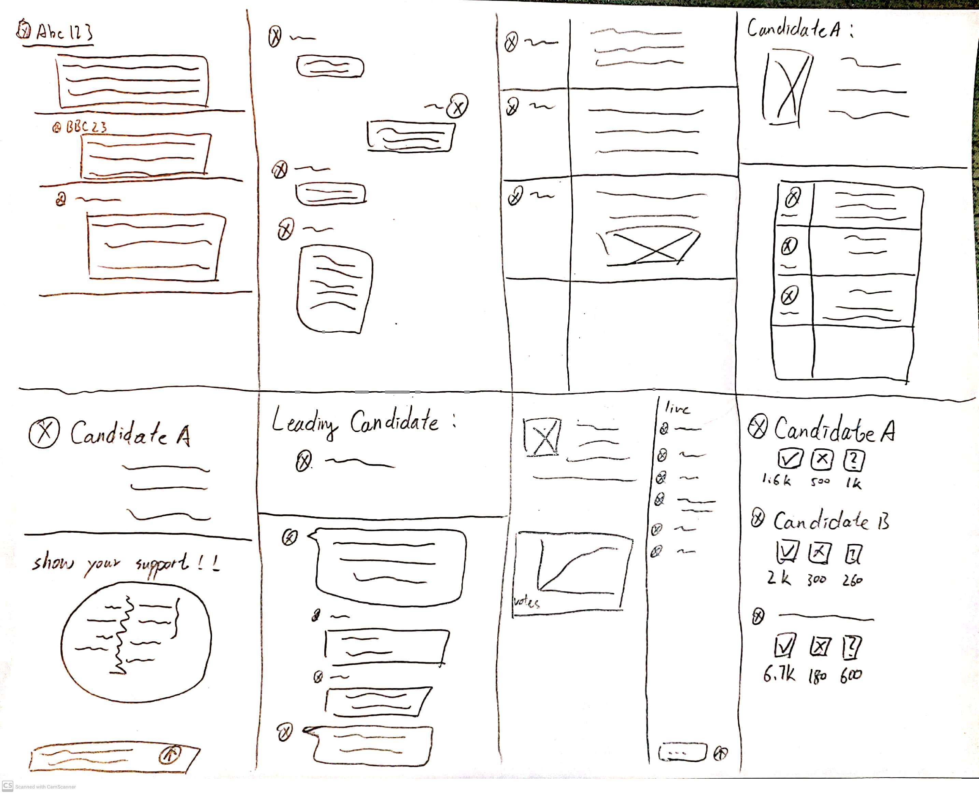

Guest comment

Solution sketch

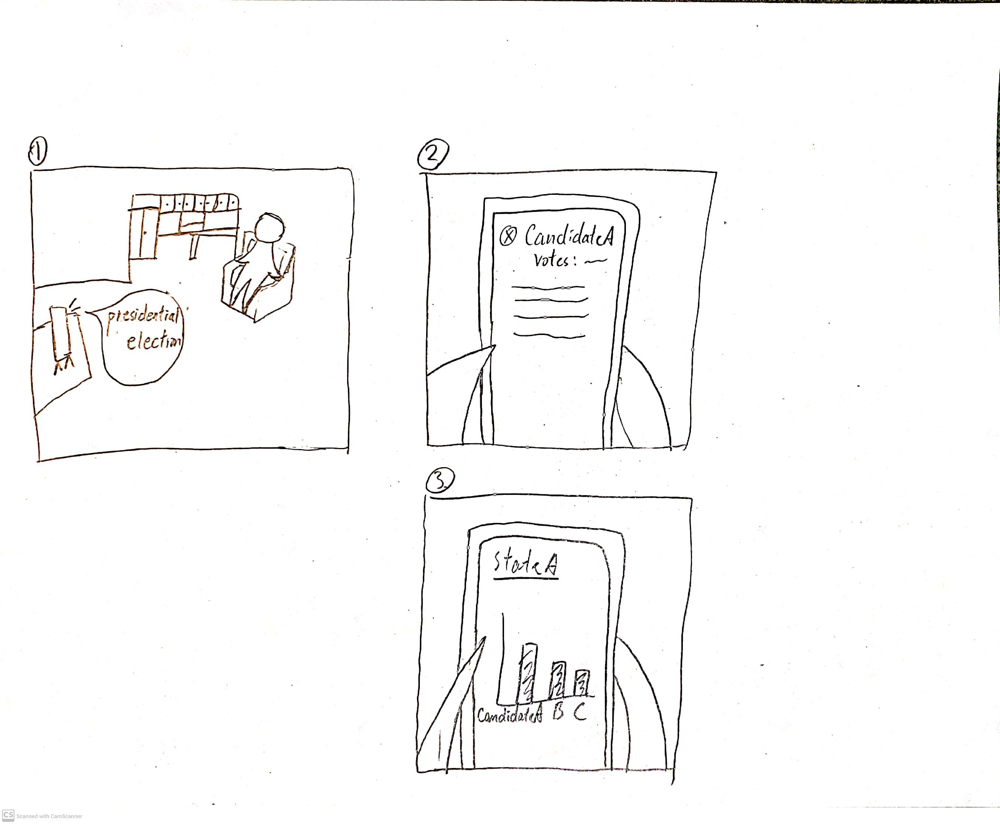

Picture 1:

The user is watching the 2020 Presidential Election podcast on TV, he wants to know more details about the election.

Picture 2:

The user opens the app and look up his favorite candidate. The app responses with the Candidate information along with the current votes that candidate have gotten.

Picture 3:

The user now wants to know how his favorite candidate is doing, in the user’s living state, compare to other candidates. The app responses with a bar-chart shows comparison with other candidates.